Kim Forrester
Holistic Well-Being Educator | Author | Speaker
Kim Forrester is a mother, nature lover, global traveller, holistic well-being advocate and kindness enthusiast. As an award-winning author, educator and consultant, she combines cutting edge science with spiritual philosophy to inspire holistic well-being and fullness of living.
She has featured in media throughout Australia, New Zealand, Asia and the USA and regularly contributes to well-being and lifestyle publications all over the world. An experienced and engaging speaker, Kim is available to talk on a wide range of wellness and lifestyle topics. She is also the host of the Eudaemonia podcast, where she takes a deep dive into the habits and traits that can help us flourish in life.
Kim earned a Diploma of Arts (Philosophy) through Massey University, and her first book, Infinite Mind, was awarded a Silver Medal in the global 2016 Living Now Book Awards.
Born in Aotearoa-New Zealand, Kim has spent more than two decades as a global citizen, living in several countries throughout Europe, South-east Asia, and the Pacific. www.kimforrester.net

Byline
Kim Forrester is an award-winning author, holistic well-being educator, and consultant. She blends science with spiritual philosophy to inspire fullness of living, and regularly contributes to well-being and lifestyle publications all over the world. Her award-winning book, Infinite Mind, is a collection of true psychic experiences and the modern research that is beginning to explain these phenomena.

Social Media

Facebook: Kim Forrester Holistic Wellness (@iamkimforrester)
Instagram: @iamkimforrester
YouTube: @iamkimforrester
Supernova: @iamkimforrester

Press Topics
- Holistic well-being: the importance of well-being from the inside, out.
- Four ways to choose happiness.
- Career or calling? How to set authentic goals.
- Authentic living: are you really being ‘you’?
- Ageing gratefully: healing our attitude toward ageing.
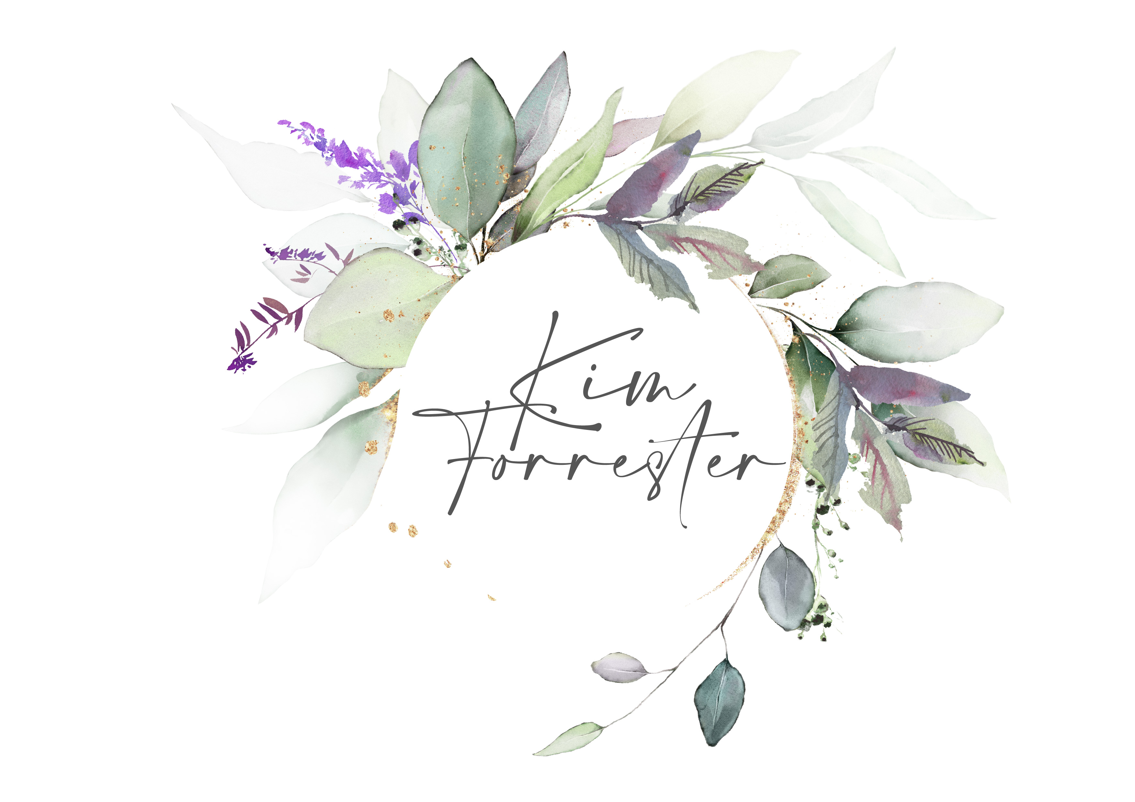
- Kindness: the ultimate superpower.
- Is success failing us? Dissecting the superficiality of modern 'success'.
- General well-being and modern spirituality topics.

